**UDACITY - Data Analyst Nanodgree**

**Overview**

In this project, I will analyze the local temperature of Makkah in Saudi Arabia and compared it with the global temperature data. I have been taken the data from Udacity portal to meet the criteria of this project.

**The used tools**

* **SQL:​** To extract the data from the database.
* **Excel:​** To look up and understand the attributes of the data to write a report of a project.
* **Python:​** To calculate the moving average and plotting a line chart.
* **ANACONDA - Jupyter Notebook**:​ To write python code and making observations.

**Extraction of Data**

Data were retrieved from the database using SQL - Structured Query Language. First, retrieve cities in Saudi Arabia to search which is the closest to where I live from city_list table by using this SQL command:

The result of previous select statement given two city Makkah and Riyadh. Second, retrieve the temperature of Makkah data from city_data table by using this SQL command:



Last, retrieve the temperature of global data from global_data table by using this SQL command:



There are two tables to analyze data which make confused due to redundancy of data. Therefore, we joined it's into one table to analyze without redundancy of data. We found the SCHEMA for both city_data and global_data table contains the same column named 'avg_temp'. So, I have changed the names of the columns respectively in order to have distinct columns and retrieve the final data from a database from multiple tables by using this SQL command:





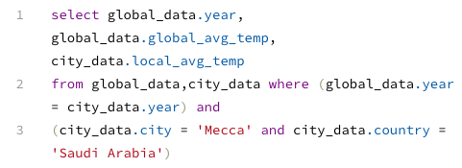

**Moving Averages:**

The rolling Average has been calculated to smooth out data and to make it easier to observe the trends for the short term when it is shown in the charts. The Moving Average has been calculated for every 15 years to every single data but the first 15 years are not included. There were some missing data in local temperature. I filled that data by calculating the mean of the values of the whole column and then filling that mean to missing cells. I have been used Python to calculate the Moving Average Using built-in Functions such as (“rolling”, “mean’).

**Line Chart for the data:**

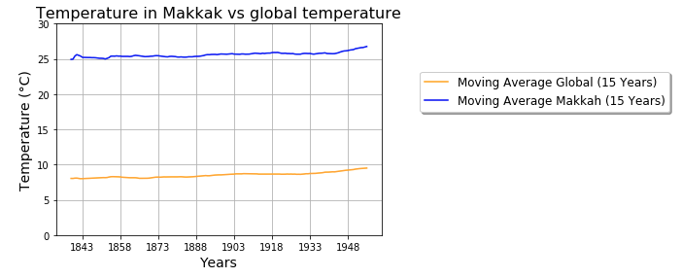

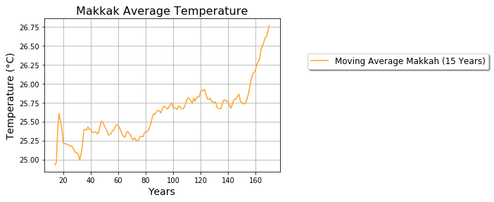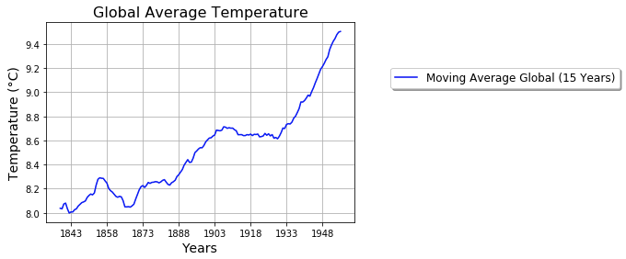

**Observations**

* My main concern to visualize the weather trends is observing an increase or a decrease in the moving average temperature.
* The global temperature trends represented in blue color whereas Makkah temperature was represented in orange color.
* Since 1875, I found that the average global and Makkah temperature is increasing over time due to climate change.
* The difference between year 1843 and ~2013 in temperature is more than 1.5 degrees in the Global average chart (increasing).
* The difference between year 1843 and ~2013 is more than 2.4 degrees in Makkah City average chart (increasing).
* The overall trends either global or Makkah are increasing gradually day by day. The world is getting hotter based on the trends above.